6 Editors introduction
How to use the Manual 1
General Manual structure 1
Editor Type 1
Editor Area 2
Menus, options, tabs and panels 3
Object Types and their modes 3

How to use the Manual

The question of how to use the manual sounds odd in the first moment. You simply read it! But there are a few things to know before you can really find easily what you are looking for. Because using a 3d software requires some special 3d knowledge. And it needs a bit of knowledge about Bforartists to understand the structure of the manual. So that you can find what you need, both, from coming the software side, and from coming the manual side.

In worst case a manual chapter looks like this:
7.3.14 Editors - 3D View - Sidebar - Tool Tab - Grease Pencil - Weight Paint Mode.
How do you supposed to find the needed information here? Why is this title so long? What is a mode, what is a sidebar, a tab? And what is a grease pencil?

Well, the manual chapter names are some sort of breadcrumbs. And you can follow this breadcrumbs. It is always the same pattern, at least for the chapters about the editor types and their tools.

Chapter number - Editortype - Editor area - Tab and panel if available - Object type - and the mode in which the object needs to be to show the tool.

And with this knowledge you should now easily be able to find what you are looking for. And this in both directions. Coming from the software and searching in the manual. And coming from the manual and searching the tool in the software.

Let's talk about the details.

General Manual structure
Chapter 1 to 6 contains some general informations. Like the official keymap. Or the general interface. The different single editor types starts with chapter 7. And at the end you will find some miscellaneous informations.

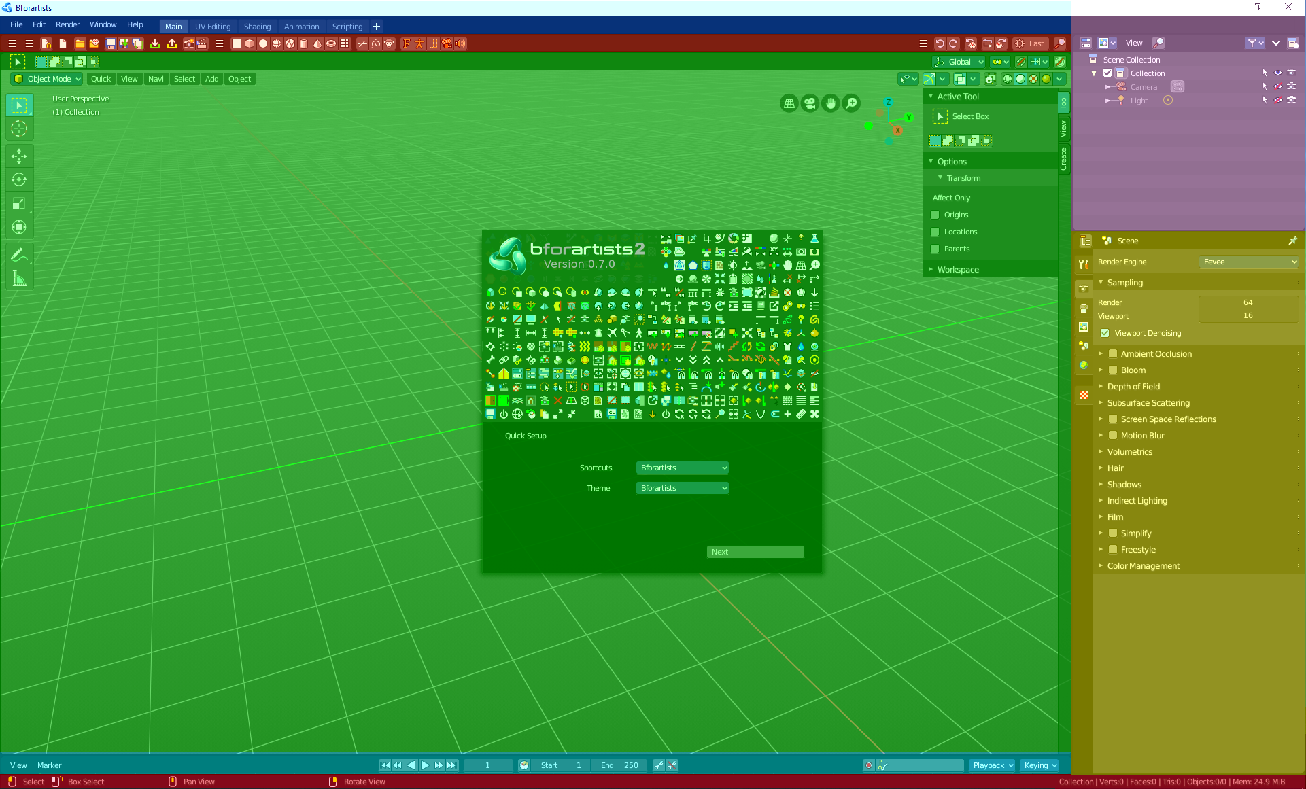
Editor Type
The different editor types is the first thing that brings structure into the manual. The different Editor tpyes.

In the shot at the right you see that Bforartists is made of several areas. These are the several editor tpyes. They all have their purpose. You have one editor type for the 3d view. One for the file browser, one for the UV editing, one for the Node editor, and so on. In this shot we see the 3D view (green), Toolbar editor (red), Outliner (pink), the Properties Editor (yellow), at the bottom the Timeline editor (blue). And the header and footer.

Each editor type has its own main chapter.
Chapter 7 is all about the 3D view. So every chapter that starts with a 7 is a chapter for the 3D view.
Chapter 8 is all about the Image Editor.
Chapter 9 is all about the UV Editor, and so on.

Please have a look in the manual chapter 6 Editors Introduction. Here we list and describe all the different Editortypes.

Conclusion
The manual chapter for the editors starts with the number. Followed by the editor type.

Example: 7 Editors - 3D View

Editor Area
Each editor can have several areas. The header, a toolbar at the left, a sidebar at the right, A tools area, the viewport to display and modify the content, some navigation elements, a panel where you can adjust some operations, and maybe even a footer.
Here as an example the 3D view.
At the top is the Tool Settings. Marked with blue. Here you can find settings for the currently active tool.
Below the tool settings is the Header. Marked with pink. It contains menus, tools and settings.
In the middle is the actual viewport. Here you see and modify for example your mesh data.
At the left you can find the Tool Shelf. Marked with green. It contains all the tools.
The yellow area is the navigate widgets.
At the right of it you can find the Sidebar. Marked with blue again. It contains settings and transform values. And it is the place where addons adds its panels.
At the bottom left you can find the Adjust Last Operation panel. Marked with red. This panel appears when you do an operation, like move the mesh to another location, and allows you to adjust the values for the operation afterwards.
Conclusion
The manual chapter for the editors starts with the number. Followed by the editor type. Followed by the area type.

Example: 7.1 Editors - 3D View - Header

Menus, options, tabs and panels
Text menus and options are usually to find in the Header. So this are logical sub chapters for all header chapters.
Tabs and panels are usually to find in the sidebar. So this is the logical sub chapters for all sidebar chapters.
Conclusion
The manual chapter for the editors starts with the number. Followed by the editor type. Followed by the area type. Followed by the subtypes in this area.

Example: 7.1.5 Editors - 3D View - Header - Select Menu
Example: 7.3.2 Editors - 3D View - Sidebar - Tool Tab

Object Types and their modes
There are several object types in Bforartists that you can work with. One of the most common object types is the mesh object.
Each object can have several modes to modify this object type. The mesh object has for example an edit mode where you can modify the mesh. A sculpt mode where you can sculpt the mesh. A vertex paint mode, a weight paint and a texture paint mode.
Each mode has its own toolset. This means that some tools just shows with specific object types and being in a mode where these tools shows.
And this is the last and very important breadcrumb in our manual chapter titles. Object type and required mode.
Conclusion
The manual chapter for the editors starts with the number. Followed by the editor type. Followed by the area type. Followed by the subtypes in this area. Followed by object type and needed mode to show these tools.

Example: 7.3.7 Editors - 3D View - Sidebar - Tool Tab - Mesh - Vertex Paint Mode

